Assignment 9
Hunter frady
11-18-2022

In this assignment we were given some basic code to put into matlab. Using the code, we were prompted to speak into the microphone and allow matlab to record it. We were able to adjust the sampling rate and filter length to create some different results. Figure 1 shows the plot of my voice with a sampling rate of 8000. My voice sounds as it was when it was recorded. As we change that sampling rate though it changes the way my voice sounds. At 16000Hz it sounds like Alvin and the Chipmunks, giving this fast and high pitch sound. At 2000Hz, its undisguisable as a voice, and sounds more like a purring cougar. When I change that value to 6000Hz, closer to our original 8000Hz the voice sounds much deeper and slower. It mimics the voice changers you would hear on a cop show when they didn’t want to give away a witness’s identification.
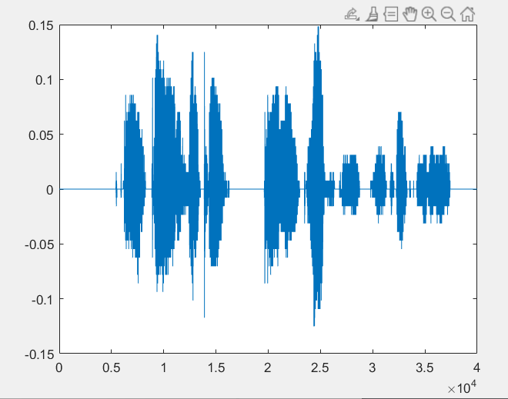
Figure 1 shows us a plot of my voice sample. X axis = Time; Y axis = Frequency

